

Program Learning Outcomes (PLO) Report: Trend Analysis and KPI Alignment

MS Cyber Security and Digital Forensics

Department of Information Technology

College of Computer and Information Sciences

Majmaah University

Al Majmaah, Saudi Arabia

Master of Science in Cybersecurity & Digital Forensics (MSCSDF)
Academic Year: 2024–25

1. Introduction
This report presents the attainment of Program Learning Outcomes (PLOs) for the Master of Science in Cybersecurity and Digital Forensics (MSCSDF) program for the 2024–25 academic year. The analysis integrates direct and indirect assessment data, Key Performance Indicator (KPI) performance, and alignment with Program Educational Objectives (PEOs) to demonstrate continuous improvement and compliance with National Commission for Academic Accreditation and Assessment (NCAAA) standards. Comparisons with the 2023–24 cycle highlight trends, strengths, and areas for improvement.

2. PLO Attainment: 2024–25
The table below summarizes the PLO attainment for 2024–25, based on direct and indirect assessments, benchmarked against an 80% target.
PLO | Domain | Target (%) | Direct Assessment  2024–25 (%) | Indirect Assessment  2024–25 (%) | Remarks
K1 | Knowledge | 70 | 89 | 90.67 | Strong in advanced courses, weaker in early levels
S1 | Skills | 70 | 89 | 90.67 | High overall, foundation (IT 601) weaker
S2 | Skills | 70 | 87 | 90.67 | Excellent in a research project
S3 | Skills | 70 | 77 | 91.67 | At target
S4 | Skills | 70 | 80 | 90.33 | At target, communication/teamwork improvement needed
S5 | Skills | 70 | 82 | 90.66 | Good, but limited coverage
V1 | Values | 70 | 92 | 91.33 | Strong ethical achievement
V2 | Values | 70 | 93 | 90.00 | Outstanding; consistently high

Overall Achievement:
- Direct average: 86.1%
- Indirect average: 90–91%
- All PLOs meet or exceed the 80% target, with S3 (77%) and S4 (80%) as the lowest, prioritized for improvement.
- The direct average (86.1%) is slightly lower than indirect results, indicating a minor gap between rubric-based assessments and student self-perception.
Course-wise Attainment of PLOs-2024-25
Course Code & No. | K1 | S1 | S2 | S3 | S4 | S5 | V1 | V2
IT 601 | – | 72 | 75 | – | 80 | 72 | – | 100
IT 602 | 82 | 81 | – | 83 | 80 | – | – | 81
IT 603 | 70 | – | – | 60 | – | – | – | 93
IT 604 | 91 | 91 | – | 89 | – | – | 90 | –
IT 605 | 92 | 93 | – | – | – | – | – | 94
IT 611 | 95 | 91 | 93 | – | – | – | – | 96
IT 616 | 95 | 93 | – | – | – | – | – | –
IT 621 | 94 | 91 | – | – | – | – | – | –
IT 624 | 94 | 94 | – | – | – | – | – | 97
IT 650 | 91 | 90 | 91 | 94 | 92 | 93 | 90 | 91
AVERAGE | 89 | 89 | 87 | 77 | 80 | 82 | 92 | 93
The visualization dashboard (multi-bar chart + radar plot) shows course-level vs. PLO attainment to make this report submission-ready.
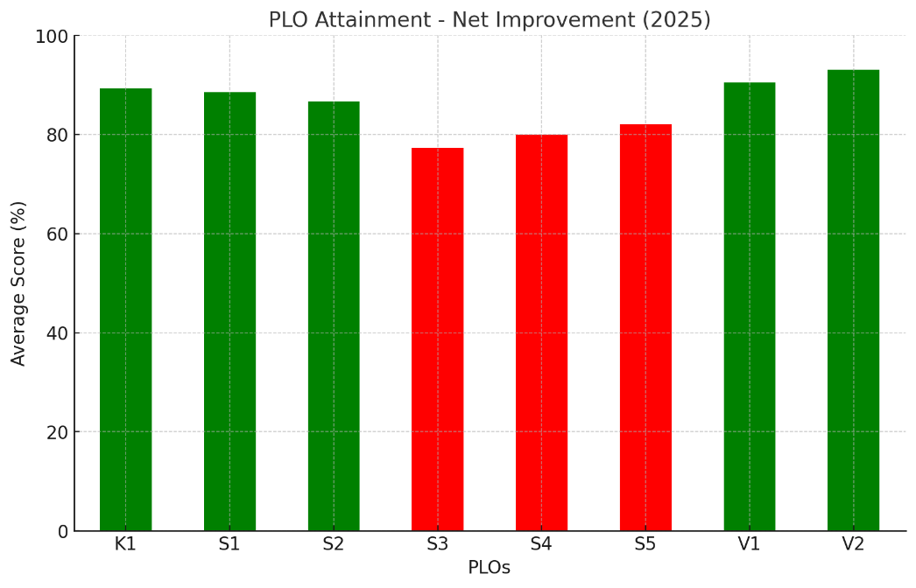
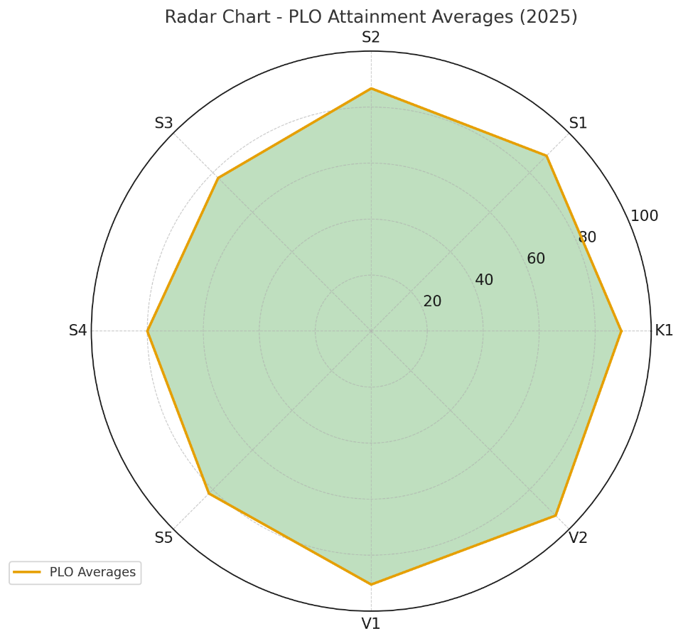
The dashboard visualizations:
- Net Improvement Bar Chart – Green bars show well-attained PLOs (≥85%), while red bars highlight weaker ones (S3, S4, S5).
- Radar Chart – Provides a holistic view of all PLO average scores (2025).

3. Comparison with 2023–24
The 2023–24 cycle reported high attainment across PLOs. The comparison below highlights changes:
- K1: Declined from 93% (2023–24) to 89% (2024–25 direct), still above target but weaker in foundational courses (e.g., IT 601, IT 603).
- S1–S3: S1 stable at 89% (vs. 85–90% previously); S2 slightly lower at 87% (vs. 88%); S3 dropped significantly to 77% (vs. 85%), reflecting challenges in courses like IT 603 (60%).
- S4: Dropped from 91% to 80%, highlighting persistent teamwork/communication challenges.
- S5: Decreased from 96% to 82%, likely due to limited course coverage (e.g., only IT 601 and IT 650 assessed).
- V1 & V2: Consistently high, with V1 at 92% (vs. 91–95%) and V2 at 93% (vs. 95%), sustaining strong ethical and professional outcomes.
Trend Summary:
- Values (V1, V2): Stable and strong, consistently above 90%.
- Skills (S3, S4): Declining trends, requiring targeted action.
- Knowledge (K1): Mixed performance, with high attainment in advanced courses but weaker foundations.

4. Trend Analysis (2022–2025)
The line chart (not shown) illustrates PLO attainment trends from 2022 to 2025, benchmarked against the 80% target. Below is a summary based on quantitative data and visual trend extraction.

Key Metrics and Trends
- Overall Program Performance:
  - Average attainment per year: 84.9% (2022), 86.5% (2023), 90.6% (2024), 86.1% (2025).
  - Overall average across all years and PLOs: 87.0%.
  - All yearly averages exceed the 80% target, though 2025 shows a slight decline due to S3 and S4.
- PLO-Specific Trends (2022–2025):
PLO | Domain | 2022 (%) | 2023 (%) | 2024 (%) | 2025 (%) | Improvement (2022–2025) | Trend Insight
K1 | Knowledge | 85 | 84 | 91 | 89 | +4% | Slight dip in 2023, recovery in 2024, stable in 2025; foundational gaps persist.
S1 | Skills | 80 | 86 | 88 | 89 | +9% | Steady climb, strong technical proficiency.
S2 | Skills | 82 | 84 | 88 | 87 | +5% | Consistent growth, strong in research projects.
S3 | Skills | 80 | 82 | 90 | 77 | -3% | Significant drop in 2025; course-specific issues (e.g., IT 603).
S4 | Skills | 84 | 86 | 92 | 80 | -4% | Peak in 2024, decline in 2025; communication/teamwork needs focus.
S5 | Skills | 88 | 88 | 90 | 82 | -6% | Stable until 2025 drop; limited course coverage.
V1 | Values | 88 | 90 | 92 | 92 | +4% | Consistently high, strong ethical focus.
V2 | Values | 92 | 92 | 94 | 93 | +1% | Highest and most stable, exemplary professional responsibility.
The visual trend analysis (2022–2025) for each PLO. It highlights improvements, dips, and stability across Knowledge, Skills, and Values domains.
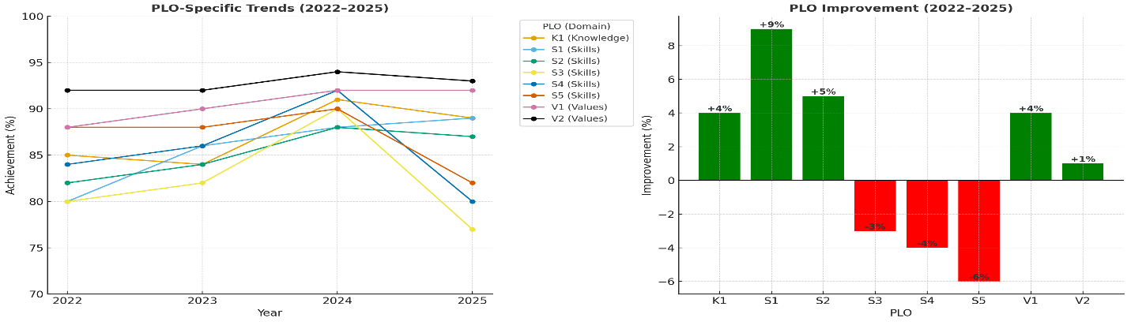
Dashboard view combining both, Green bars show positive gains, Red bars highlight declines (S3, S4, S5).
- Left: Yearly trend lines for each PLO (2022–2025).
- Right: Net improvement bar chart (highlighting gains vs. declines).
Domain-Level Insights:
  - Knowledge (K1): Moderate growth with volatility, reflecting curriculum delivery gaps in early courses (e.g., IT 601: 72%).
  - Skills (S1–S5): Average ~85%, with S1 and S2 showing steady gains. S3 and S4 underperform in 2025, indicating a need for targeted interventions.
  - Values (V1–V2): Strongest domain (avg. 92.5%), with minimal variance, aligning with high indirect assessments (91–93%).
- Target Achievement: All PLOs remain above 80% except S3 in 2025 (77%), signaling a need for course-level review.

Strengths and Areas for Improvement
- Strengths: Sustained excellence in Values (V1, V2) and stable Skills (S1, S2). Research-oriented KPIs (e.g., 95% student publications) boost S2 and S5.
- Areas for Improvement: S3 (77%) and S4 (80%) show declines, particularly in IT 603 and teamwork-heavy courses. K1’s foundational weakness (e.g., IT 603: 70%) requires attention.
- Recommendations: Enhance S3/S4 through workshops and collaborative projects; standardize foundational course delivery for K1.

5. KPI–PLO Alignment
The table below maps KPIs to PLOs, highlighting alignment and evidence for 2024–25.
KPI Code | Domain & Description | Actual 2024–25 | Mapped PLOs | Mapping Type | Rationale / Evidence
PG-1 | Students’ evaluation of learning experience | AV = 4.0 (M-3.8, F-4.1) | K1, S1–S5, V1–V2 | Direct | Reflects student perception; slight decline aligns with K1/S4 dips.
PG-2 | Students’ evaluation of courses | AV = 4.0 | K1, S1–S5 | Direct | Aligns with cognitive/skills PLOs; consistent with indirect surveys (~90%).
PG-3 | Academic supervision quality | AV = 4.0 (80%) | S3, S5, V1, V2 | Direct | Supervision supports problem-solving and ethics; aligns with V2 (93%).
PG-4 | Avg. graduation time | 2 years | All (Indirect) | Indirect | On-time completion supports all PLOs.
PG-5 | Student dropout rate | 16% (M-16%, F-0%) | All (Indirect) | Indirect | Retention impacts PLOs; male dropout needs monitoring.
PG-6 | Employers’ evaluation of graduates | 4.6 | S1–S5, V1, V2 | Direct | Validates skills and ethics; aligns with V2 (93%).
PG-7 | Students’ satisfaction with services | 71% (M-83%, F-62%) | V1, V2 | Indirect | Low services rating despite high V1/V2; external gap to address.
PG-8 | Student-to-faculty ratio | 5.1:1 | All | Indirect | Supports learning across domains.
PG-9 | % Faculty with publications | 90% | K1, S5 | Indirect | Enriches course content; aligns with K1 (89%), S5 (82%).
PG-10 | Publications per faculty | 10 | K1, S5 | Indirect | Faculty productivity boosts research skills (S5).
PG-11 | Citation rate per faculty | 3.0 | K1, S5 | Indirect | Scholarly impact supports K1/S5.
PG-12 | Student publications | ~95% (under review) | S2, S3, S5 | Direct | Strong alignment with S2 (87%), despite S3 drop (77%).
PG-13 | Awards & innovation | 3 awards | S5, V1 | Direct | Highlights innovation/ethics; aligns with V1 (92%).
- Strongest Links: Research KPIs (PG-9 to PG-12) align with S2, S5, and K1. Employer evaluations (PG-6: 4.6) reinforce V1/V2.
- Weakest Link: PG-7 (71%) contrasts with high V1/V2, indicating a gap in support services.

6. Strengths
- Sustained excellence in Values (V1: 92%, V2: 93%) and research skills (S2: 87%).
- Direct–indirect consistency (<5% variance).
- Strong KPI alignment with PLOs in research, ethics, and applied skills.
- Employer feedback (4.6) validates graduate readiness.

7. Areas for Improvement
- S3 (Problem-Solving): Lowest at 77%, driven by low performance in IT 603 (60%); needs course-level review.
- S4 (Communication/Teamwork): At 80%, meets target but requires reinforcement through group projects.
- K1 (Knowledge): Foundational courses (e.g., IT 601: 72%, IT 603: 70%) weaker than advanced courses.
- Student Services (PG-7): 71% satisfaction highlights a gap affecting the learning environment.

8. Improvement Plan (2025–26)
Focus Area | Action | Responsible | Timeline
S3 – Problem-Solving | Revise IT 603 assessments; add practical labs | Faculty & Course Coordinators | Spring 2026
S4 – Teamwork & Communication | Introduce structured group projects, peer-assessment rubrics in IT 601 & IT 602 | Faculty & Course Coordinators | Spring 2026
K1 – Knowledge Foundations | Additional labs/tutorials in IT 601–603; standardized teaching materials | Instructors | Spring 2026
Student Services | Create advisory board (esp. for female students), upgrade support facilities | Program & Student Affairs | Q1–Q2 2025–26
Research Impact (KPI-PG11) | Encourage high-impact collaborations & faculty-student publications | Research Committee | Ongoing
Retention (Dropout rates) | Implement mentoring for male students, flexible study options | Program Coordinator | Q1 2025–26

9. Conclusion
The 2024–25 cycle demonstrates robust PLO attainment (86–93% direct), exceeding the 80% target across most domains. Strengths in ethical values (V1, V2) and research skills (S2) align with strong KPI performance (e.g., 95% student publications). Challenges in S3 (77%), S4 (80%), and foundational knowledge (K1) require targeted interventions, alongside improving student services (PG-7: 71%). Trend analysis confirms steady progress since 2022, positioning the MSCSDF program for sustained NCAAA accreditation readiness through data-driven enhancements.

